2015 June Southeast Alaska Coastal Monitoring (SECM) survey

"The contents of this report are mine personally and do not necessarily reflect any position of NOAA."
Joe Orsi
All scheduled stations were successfully completed during the late June Southeast Alaska Coastal Monitoring (SECM) project survey from 26 June to 03 July 2015. Scientists participating onboard the chartered survey vessel Northwest Explorer were: Ryan Bare (NOAA Contractor), Kris Cieciel (NOAA), Emily Fergusson (NOAA), Jamal Moss (NOAA), Joe Orsi (NOAA), and Leon Shaul (Alaska Department of Fish and Game). A total of 33 stations were sampled, covering three line transects: one offshore (Icy Point) and two along a seaward migration corridor (Icy Strait and Upper Chatham Strait), and the Auke Bay Monitoring station in Southeast Alaska (SEAK). Replicate sampling was conducted within the seaward migration corridor as planned and a modified Marine Mammal Exclusion Device (MMED) was used offshore. Live zooplankton taxa was again sampled and retained to identify lipid content of salmon prey as an annual ecosystem metric.

Of the total salmon catch, 12,136 juveniles were sampled (all five species) as were small numbers of immature (8 Chinook and 12 chum), and adult (76 pink, 19 chum, and 2 sockeye) salmon. Sizes of all species of juveniles were some of the largest we have seen in June over the SECM time series. Water temperatures (both upper 20-m integrated and 3-m) were over 1ºC above the 18-yr SECM average at both coastal and inshore sampling localities. The adult pink salmon sampled were also larger than normal this survey and the occurrence of the ocean sunfish (Mola mola) and Market squid in the coastal waters of the northern region of SEAK near 58º N in late June is noteworthy and suggests an early northward movement of some warm water fish species.

Icy Point--One hour of experimental squid jigging at midnight was conducted offshore near the end of the Icy Point transect over 1500 m of water with no catches (3 rod hours). The next morning, at the furthest offshore station of the coastal Icy Point transect (65 km offshore, IPD), one large ocean sunfish (800-1,000 lbs.) was sampled and released (8.5 feet wide and 7.5 feet long), and twelve 1-ocean immature chum salmon were also sampled. At the other three stations further inshore along the Icy Point transect, the following numbers fish and squid were sampled: all five species of juvenile salmon totaling 221, 16 Hexagramid spp., 6 spiny dogfish, 2 sablefish, I rockfish, 1 lingcod, 3 market squid, and 7 small unk. Squid. Of the salmon sampled in the coastal transect, one coded-wire tagged (CWT) juvenile Chinook salmon was recovered 40 km offshore (IPC) from the Santiam River, upper Willamette R., OR: a spring-run 2013 brood year fish released on 15 March 2015 and recovered a little three months later on 29 June over 1,800 km northward.

Pictured below (market squid and Mola mola off Icy Point, and juvenile salmon and age 1+ Pollock in Icy Strait)

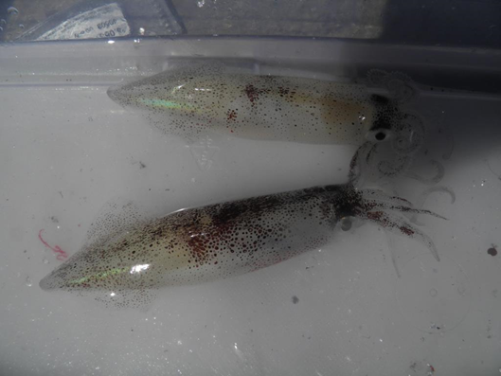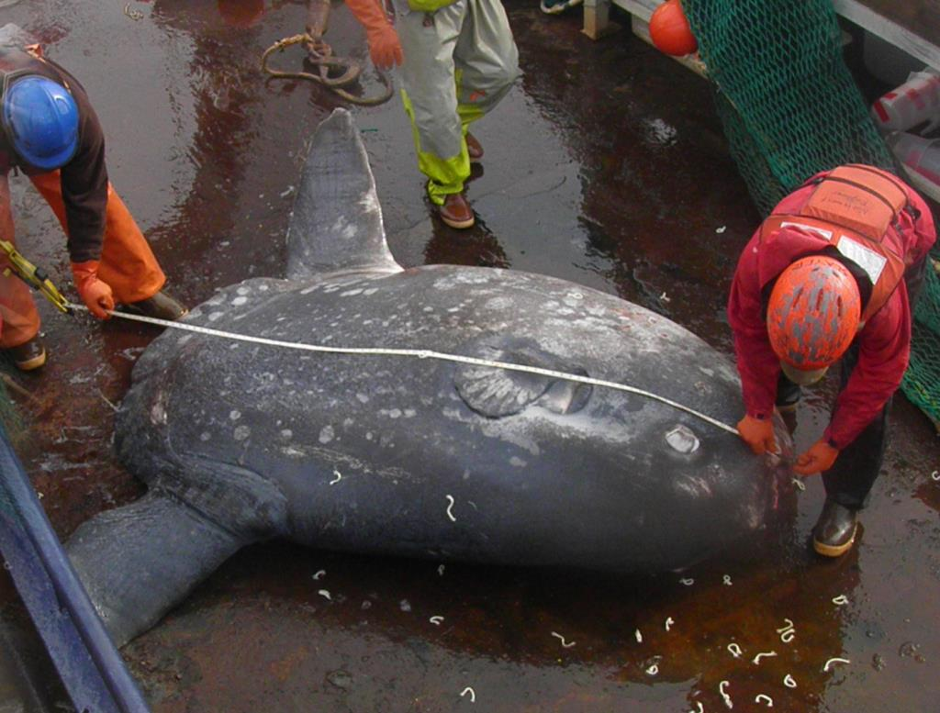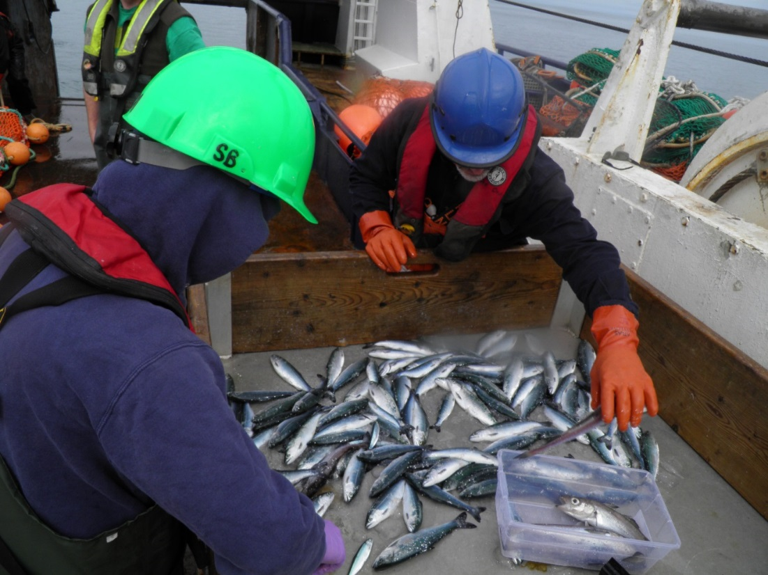

Icy Strait--Fish catches along the replicated Icy Strait and Upper Chatham Strait transects were: 11,919 juvenile salmon (52% chum, 29% pink, 10% sockeye, 9% coho, and <1% Chinook), 1,019 age-2 walleye pollock, 8 Pacific herring, 7 crested sculpin, 4 Dolly Varden, 2 smooth lumpsuckers, and 2 soft sculpin. Juvenile salmon species sampled this month were ~20% larger than average sizes in the 18-yr SECM time series, suggesting juveniles entered the ocean early in 2015 and were met with favorable growing conditions. There were 21 CWT juvenile coho salmon and 1 CWT juvenile Chinook salmon recovered in Icy Strait that originated from hatchery and wild SEAK stocks.

